Output for: To select employee details based on the DepartmentID:

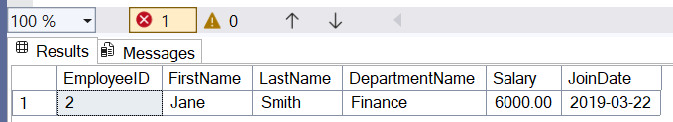

Output for: Inserting new data in the table:

